Se non leggi correttamente questo messaggio, clicca qu

[i](https://customer44244.musvc1.net/e/r?q=R6%253dEBR7P_0yjw_K9_9xkx_IC_0yjw_JDuatbu.JsG3R8A3FwLA.07K_9xkx_ICx_Phzh_ZwO6J.rP8V_9xkx_IC_0yjw_KDzDv_Phzh_auN9UFU_._0yjw_K9xC_0yjw_KB8_8yf_9xkx_JA9SGRD_fraR._Phzh_au8N_Phzh_araFQCWF0_9xkx_IcF_Phzh_auM8_Phzh_ZMQH_Phzh_arBzDzKRAseKhy__Oi1g_Zsev_Oi1g_ZvPFVCOejdu%2526t%253daLZKa%2526v%253dKBPDAH.KwR%2526zP%253dJgPbK%2526J%253dH%2526K%253dIcQbP%2526M%253dHXOgQ%2526Q%253d-9r8sIYNeOZIcMc&mupckp=mupAtu4m8OiX0wt)

**Federazione Gilda-Unams**

**SNADIR NEWS**

**ULTIME NOTIZIE**

**NEWS n.134 h.11,15**

**1**

**° febbraio**

**2022**

**All'Albo Sindacale ex art. 25 legge 300/1970**

**Si invia quanto in oggetto, chiedendo di inoltrarlo**

**a tutti i docenti di religione**

**del vostro Istituto**

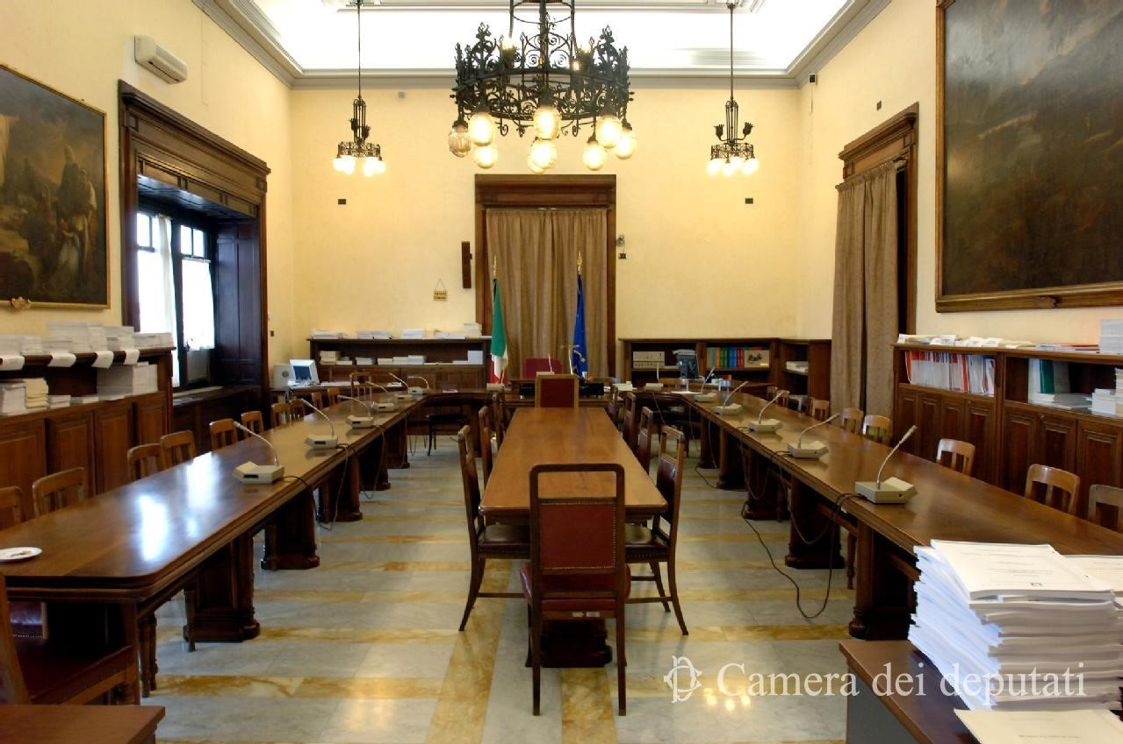

|  |  |  |
| --- | --- | --- |
|  |  |  |
|  |
|  |

Inviato con



**Unsubscrib**

[**e**](https://customer44244.musvc1.net/e/r?q=M5%253d9yM6J_wtiq_84_8rXs_H7_wtiq_79tUgWt.DfB2Lu620jG0.4tF_8rXs_H7k_KgtU_UvFtN.qJuQ_8rXs_H7_wtiq_89_8rXs_I2B_KgtU_VtFvPEQ4_KgtU_VqX._wtiq_84u9_wtiq_877__IVvf_TfXr._IVvf_TiJAOzQ__8rXs_HW70_8rXs_HW_wtiq_878W1KAX5LGH0N0RyS9J6X4q2f8Y9TMPxH0KALBN1NddQp%2526s%253dU9UJU%2526i%253dFAJ16G.EjM%2526yJ%253d7bOV8%2526E%253dG%2526E%253d6XPVC%2526H%253dGRBbP%2526K%253dAYGZBaMSC&mupckp=mupAtu4m8OiX0wt)

|

**Disiscrivit**

[**i**](https://customer44244.musvc1.net/e/r?q=M5%253d9yM6J_wtiq_84_8rXs_H7_wtiq_79tUgWt.DfB2Lu620jG0.4tF_8rXs_H7k_KgtU_UvFtN.qJuQ_8rXs_H7_wtiq_89_8rXs_I2B_KgtU_VtFvPEQ4_KgtU_VqX._wtiq_84u9_wtiq_877__IVvf_TfXr._IVvf_TiJAOzQ__8rXs_HW70_8rXs_HW_wtiq_878W1KAX5LGH0N0RyS9J6X4q2f8Y9TMPxH0KALBN1NddQp%2526s%253dU9UJU%2526i%253dFAJ16G.EjM%2526yJ%253d7bOV8%2526E%253dG%2526E%253d6XPVC%2526H%253dGRBbP%2526K%253dAYGZBaMSC&mupckp=mupAtu4m8OiX0wt)